Project Report

1.Introduction:
1.1: Project background

2. Analysis and Design
2.1: Research Review

3. Milestones&Project plan
3.1 Overall Development Strategy
This project will follow an incremental development strategy. The system will be divided into multiple modules that can be developed and tested independently. In early stage, our team will focus on building the minimum viable prototype. After that, the system will be gradually refined with robust code generation and correction mechanisms.

3.2 Week 8 milestone
By the 8th week, we plan to complete a minimum feasible prototype system, which could be able to recognize natural language task descriptions, build prompts, generate Arduino C/C++ sketches, and compile the generated code using Arduino command line tools.
The milestone of week 8 will focus on verifying the feasibility of the core workflow. In this stage, the system is expected to support a limited number of common hardware tasks, such as reading temperature and humidity data and controlling LEDs. The structured knowledge table will cover a small number of modules, such as Arduino Nano 33 BLE Sense board, temperature and humidity sensors.
At the same time, the system will also implement an initial feedback loop. When the compiled code generation fails, the error message will be fed back to the LLM for correction. It is estimated to test about 10-15 natural language tasks to evaluate the success rate of initial compilation and identify common failures.
The expected Week 8 outcomes are:
1. A practical prototype can generate code from natural language;
2. A preliminary structured API knowledge base integrated with Arduino compilation toolchain;
3. An initial compilation error feedback mechanism with preliminary testing results on a small benchmark and one complete workflow demonstrated;

3.3 Final milestone
The final milestone is to complete and evaluate an LLM-driven embedded software development system. Compared with the prototype in week 8, the final version will contain a more complete knowledge base, a stronger feedback loop, a larger task benchmark, and a systematic assessment of the generated code.
In the final demonstration, the system is expected to support more embedded IoT tasks, and the knowledge base will contain more structured information about selected Arduino libraries, required inclusion statements, key API functions, and common usage restrictions.
The final version will also include more complete compilation and repair loops. The system will be able to capture the compilation error, feed it back to LLM, and allow multiple repair attempts within the maximum number of predefined iterations. This mechanism will be compared with the baseline method that directly prompts LLM without providing compilation feedback to evaluate whether the feedback loop improves the compilation success rate and task completion rate.
The final evaluation will be based on a benchmark task, which contains about 30-50 natural language requests of 3 difficulty levels. Evaluation indicators include code relevance, compilation success rate, task completion rate, number of repair iterations, delay and approximate word element cost. Two language learning models will be compared to examine the trade-offs between performance, response time and cost.

3.4 Implementation timeline
Period | Focus | Expected output
Before week 5 | Requirement analysis, research review, system architecture, preliminary report preparation | Preliminary report and proposal presentation
Week 5 | Development environment setup and initial LLM interface | Working toolchain and initial code generation interface
Week 6 | API knowledge base and prompt template design | Initial API table and prompt template
Week 7 | MVP integration and Week 8 demo preparation | MVP completed before Week 8
Week 8 | Progress demo and feedback collection | Updated implementation plan
Week 9 | Benchmark expansion and model comparison | Improved feedback loop and initial evaluation
Week 10 | Final integration, hardware validation, and report figures | Final evaluation results and demo preparation
Week 11 | Final demonstration and interview | Final project and documentations

3.5 Team responsibilities and progress tracking
Project tasks will be divided based on the technical roles. One member is responsible for Arduino toolchain and hardware testing, one member is responsible for the structured API knowledge base, one member is responsible for prompts and LLM interactive modules, one member is responsible for testing task sets and evaluation indicator design, and another member is responsible for documents, presentation preparation and result analysis. Although each member has its main responsibilities, system integration and testing will be completed by the team to ensure that the modules can work together.
The progress will be tracked weekly based on the timeline. Maintain standups to update the task progress and blockers every week. At the end of a week, the team will check planned task progress, record the problems encountered in implementation process, and adjust following tasks if necessary. For technical tasks, the progress will be evaluated by observable results like whether the generated program can show expected behavior on the selected hardware.

4. Risk analysis
4.1 Hardware and Library Knowledge Errors

5. Demo/交付物
The final demo will show an embedded IoT system which is based by LLM supported. The customers could use natural language to describe a IoT mask, and input the basic hardware information, such as the microcontroller board, sensor or actuator type, and pin connections. The system will generate the embedded code to suit target device with these information. The demo focus on showing this system how to reduce Manual coding work, and supports code generation, library dependency selection, and basic validation.
The planned Demo scenario will use a simple sensor-based IoT application, such as reading data from temperature and humidity sensors and displaying or transmitting it through the device. During the demonstration, users first need to input the task requirements, and then system will generate the corresponding code. Finally, the code will be tested on the selected hardware platform. The Demo will also display whether the code can be successfully compiled and whether the actual behavior of the device complies with the task requirements.
The mainly deliverables of this project include：
1.A functional prototype system capable of receiving user task descriptions and hardware configuration information.
2.A code generation module that can generate embedded C/C++ or MicroPython code for selected IoT tasks.
3.A basic library dependency selection mechanism to support common sensors and hardware modules.
4.A set of test cases covering different types of hardware tasks, such as sensor reading, LED control, button input, and simple communication.
5.A Demo video or live demonstration showing the complete process from user input to code generation and then to device operation.
6.Project documentation explaining the system design, implementation process, test results, limitations, and future improvement directions.
The final goal of this project is not to achieve a commercial-level embedded development platform, but to achieve a proof-of-concept prototype to demonstrate that the automated method based on LLM can assist in the development of embedded IoT software. The project will be evaluated mainly based on the relevance, compilability of the generated code, and whether the code can achieve the expected hardware behavior in the selected test cases.

6.References
[1] L. Atzori, A. Iera, and G. Morabito, “The Internet of Things: A survey,” Computer Networks, vol. 54, no. 15, pp. 2787–2805, Oct. 2010, doi: 10.1016/j.comnet.2010.05.010.
[2] J. Gubbi, R. Buyya, S. Marusic, and M. Palaniswami, “Internet of Things (IoT): A vision, architectural elements, and future directions,” Future Generation Computer Systems, vol. 29, no. 7, pp. 1645–1660, Sep. 2013, doi: 10.1016/j.future.2013.01.010.
[3] A. Vaswani et al., “Attention is all you need,” in Advances in Neural Information Processing Systems, vol. 30, 2017.
[4] M. Chen et al., “Evaluating large language models trained on code,” arXiv preprint arXiv:2107.03374, 2021.
[5] J. Austin et al., “Program synthesis with large language models,” arXiv preprint arXiv:2108.07732, 2021.
[6] P. Lewis et al., “Retrieval-augmented generation for knowledge-intensive NLP tasks,” in Advances in Neural Information Processing Systems, vol. 33, pp. 9459–9474, 2020.
[7] S. Yao et al., “ReAct: Synergizing reasoning and acting in language models,” in International Conference on Learning Representations, 2023.
[8] H. Yang, M. Li, M. Han, Z. Li, and W. Xu, “AutoEmbed: LLM-driven automated software development for generic embedded IoT systems,” in Proceedings of the ACM/IEEE International Conference on Embedded Artificial Intelligence and Sensing Systems (SenSys ’26), Saint Malo, France, May 2026, doi: 10.1145/3774906.3800466.

1 Guangyu Ma
2 yichen ma
3 Huaixuan Hu
4. Sijun Chen
5&6 Jianyang Dong

3 报告该有哪些段落,各写什么
- 标题 + 小组成员(谁负责哪块)。

- 引言 / 问题陈述(对应 Topic Definition 20%):用大白话讲清楚——嵌入式 C/C++ 难写、门槛高,你们要做一个 LLM 工具让人用自然语言为 Nano 33 BLE Sense Rev2 生成 C/C++。明确写清做什么、不做什么(做:5 个板载传感器 + BLE、API 小抄、自我改错循环、30–50 条任务集、两组对比;不做:AutoEmbed 那套 7000 库检索、多板扩展)。

- 背景与相关工作(对应 Background 30%,花最多精力):概述 AutoEmbed(三个方法 + 它的结果),并放进相关研究里(LLM 写代码、LLM 做嵌入式、Englhardt 那篇 human-in-the-loop 当对照),论证你们的方案为什么合适。这段要让读者看懂后面的设计。引用挑精的,别堆。

- 方案与系统设计:放我们前面那张流水线图(自然语言→提示生成→Coder→编译循环→烧录循环→可跑的 sketch,加上 API 知识库和反馈),配文字说明。

- 实现计划 + 时间线 + 里程碑(对应 Project Plan 25%):带"资源 + 时长"的里程碑表 + 分工(见下方模板)。

- 风险评估:rubric 明确加分项,很多组栽在这里,务必认真(见下方模板)。
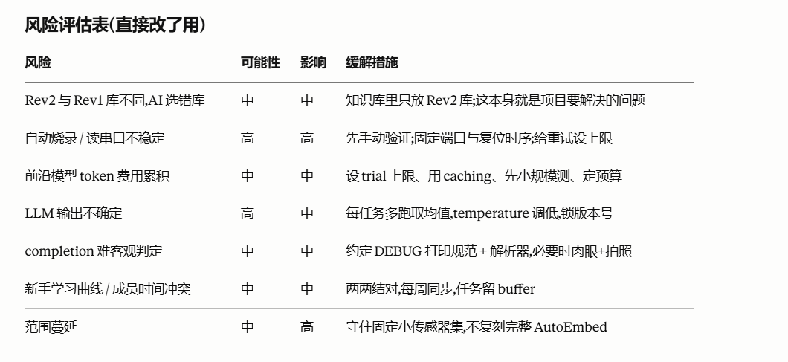

- Demonstration goals:简介强制要求——写清最终 demo 要演示什么(现场输入一句话→自动生成/编译/烧录→板子真做出对应行为;现场制造一个错误展示循环修好它;展示任务集指标和两组对比图)。

- 参考文献:统一 IEEE 或 ACM 格式(对应 Presentation 25% 的一部分)。

